**Dough Disco!**





**What is dough disco?**

Dough disco involves moulding play dough in time to music and performing different actions such as rolling it into a ball, flattening it, putting each individual finger into the dough, rolling it into a sausage and squeezing it.

**Why do dough disco?**

This activity helps to strengthen children's fine motor muscles to enable them to develop their pencil grip which in turn will help to develop their writing skills. But most of all it's fun!

**When do we do dough disco?**

In Nursery and Reception we do it for five minutes a day. Morning Nursery and Reception do it first thing in the morning. Afternoon Nursery do it at the beginning of the session.

**What do you need to do a dough disco?**

**Music –** Any song will do! We have had Abba, One Direction, Girls Aloud, McFly and Take That to name a few of our favourites!

**Dough –** You can buy pots of dough or make your own with your child. See the recipes below to help!

**A set of moves!** **-** These can be done in any order and you don’t need to include them all!

**Recipe for play dough - cooked**

**Ingredients:**

* 1 cup of salt
* 2 cups of water
* 2 tablespoons of cream of tartar
* 2 cups of flour
* 2 tablespoons of oil
* Food colouring



**Directions:**

* Mix the flour, salt, cream of tartar and oil in a pan.
* Mix the water with the food colouring.
* Add the water and food colouring mix to the other ingredients, stir well.
* Cook on medium heat for 4-5 minutes, while constantly stirring.
* When the mixture becomes “doughy”, remove from heat and start kneading. (the dough will be hot, so mind your hands)
* When desired texture is achieved, the play dough is finished, enjoy your dough disco

**Recipe for play dough - uncooked**

**Ingredients:**

* 1 cup of salt
* 2 cups of hot water
* 2 tablespoons of cream of tartar
* 2 cups of flour
* 2 tablespoon of oil
* Food colouring



**Directions:**

* Mix the flour, salt, cream of tartar and oil in a large mixing bowl.
* Mix the water with the food colouring.
* Add the water/colour-mix to the other ingredients, stir well.
* Stir continuously until it becomes dough.
* When the mixture has cooled start to knead. Knead it until the stickiness has gone. Add more flour if it remains a little sticky.
* When desired texture is achieved, the play dough is finished, enjoy your dough disco!

**Dough disco moves!**

**Roll** the dough into a ball using both hands.

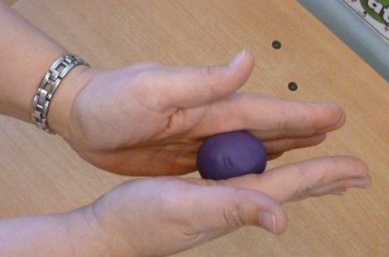 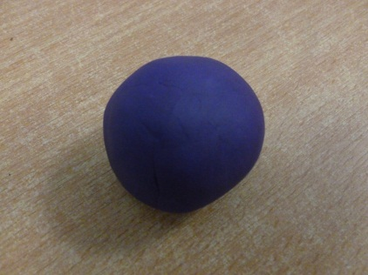

**Poke** the dough with each finger and thumb in turn to make holes in the dough. Make sure you swap hands so all fingers and thumbs are used. Extend by using names of fingers and thumb:

* Tom Thumb
* Peter Pointer
* Toby Tall
* Ruby Ring
* Baby Small

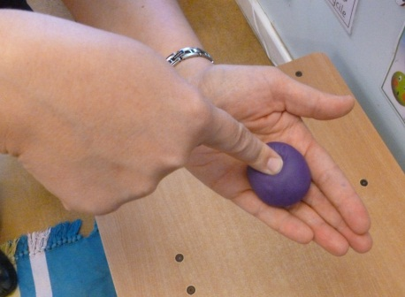 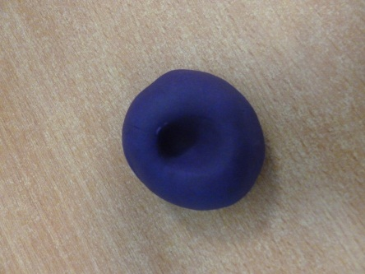

**Squeeze** the dough with all the fingers and thumb using a fist grip one hand at a time.

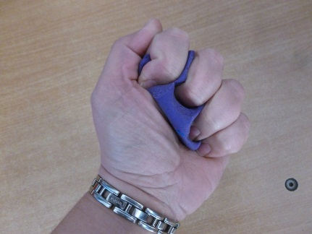 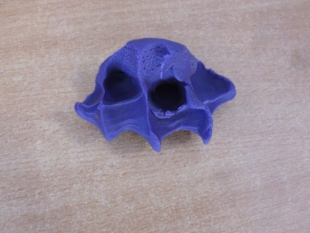

**Sausage**! Roll the play dough between both hands moving backwards and forwards to make a sausage.

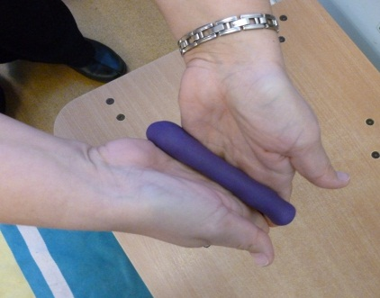 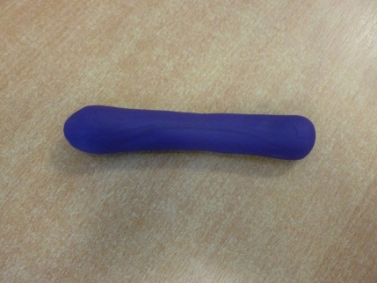

**Pancake!** Hold the play dough in one hand and push the other hand flat into the play dough. Repeat this until the dough is flatter!

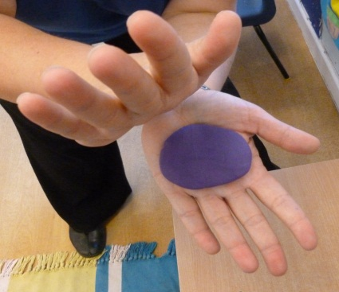 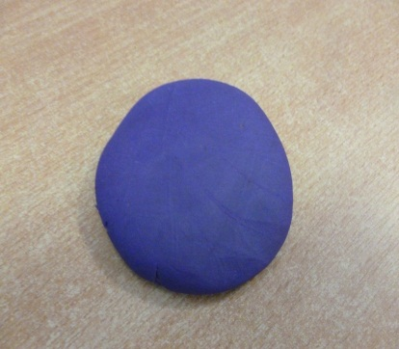

**Pinch the play dough.** Hold the play dough in one hand and use Tom Thumb and Peter Pointer to pinch the dough. Then swap hands and repeat.

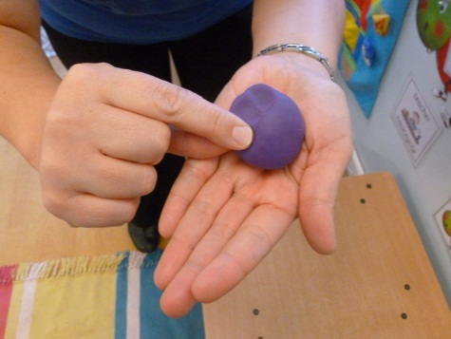 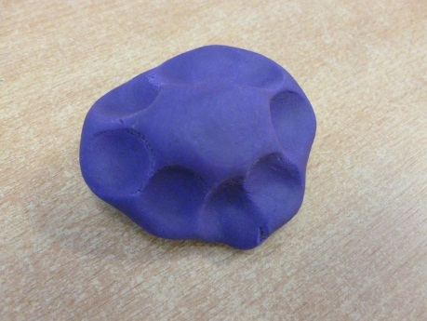

**Try it at home!**

You have nothing to lose but all to gain by doing dough disco at home! The children will develop the muscles in their hands to help them with their pencil grip which will help them with their handwriting! Five minutes a day will help to give your children the skills they need to become happy and successful writers! Give it a go and have some fun!

If you have any questions please come and speak to me.



Happy dough disco!

Mrs Edwards

EYFS co-ordinator