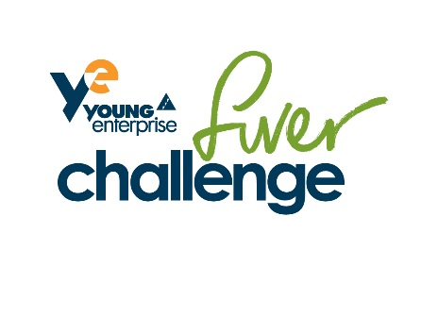

Dear Parent(s)/Carer(s)
At Tilston Parochial C of E Primary School we believe in the importance of helping our pupils to understand the world they live in and begin the process of preparing them for their future lives.
To help us we are participating this year in the Fiver Challenge run by Young Enterprise(www.fiverchallenge.org.uk). Young Enterprise is the UK’s leading enterprise and financial education charity, helping young people to develop the skills they need for life and work.
Fiver gives your child a chance to set up a mini business to create products or services they can then sell/deliver at a profit and engage with their local community. The children are in full control of any profits they make and will decide what they would like to spend them on. Fiver includes a national competition and young people from all over the country will be involved.
The Fiver Challenge takes place from 5 to 30 June 2017; please see our class blog to keep up to date with what is happening. Any support and encouragement you can give your child during the activity would really help maximise their learning from the experience
Yours faithfully

Rachel Corlett

