*Journeys:*

* *Vikings*
* *Shackleton’s Polar Expedition*



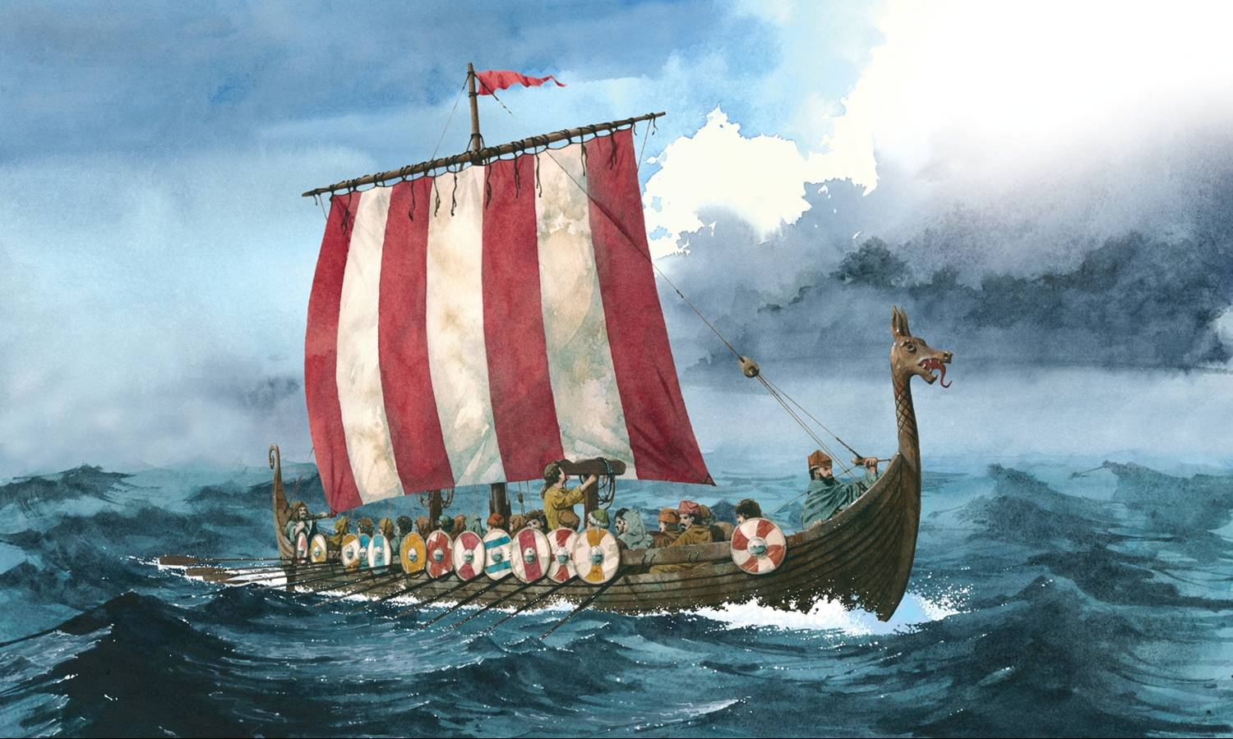

Homework

Homework will continue to be set on a two weekly rota.

**Week 1:**

* **Spellodrome**
* **Class spellings**
* **Mathletics**
* **Spelling, Punctuation and Grammar Workbook.**

‘Mathletics’ is proving to be a very successful resource. Please continue to encourage your child to complete activities on here as much as possible. Please remember that **x tables are now a non-negotiable.** It is imperative that your child knows all of their times tables by now.

**Week 2:**

* **Spellodrome**
* **Class spellings**
* **Maths Workbook**

Alongside this, Year 5/6 are expected to read daily at home.

During the term, Year 6 children will have additional revision to assist them with preparation for the end of key stage statutory assessment tests (SATs).

If you foresee access to the Internet being a problem, please let us know.

Below are useful child-friendly websites for extra learning:

<http://www.sats-papers.co.uk/sats-papers-ks2.php>

<http://www.bbc.co.uk/bitesize/ks2/maths/>

<http://www.maths-games.org/>

*Spring*

*Term*

*Kestrel*

*Class*

**Maths:** As mathematicians, this term we will develop our understanding of fractions, decimals and percentages. During cookery sessions, we will also learn more about ratio and proportion and measures.

We will also be reading timetables and solving problems involving converting between units of time; therefore the ability to tell the time is essential. **Consequently, we would request that all children wear a watch for school each day.** Please come and have a chat with me if there is a problem with this.

**English:** As authors, we are basing our reading and writing around a wonderful book detailing ‘Shackleton’s Journey’.

**PE:** PE is scheduled for a Monday and a Wednesday, however times can change. Please ensure that your child had the correct PE kit (white top and black shorts) in school at all times.

This term we will be working on basketball/netball, Sports Hall athletics, gymnastics/dance and cricket.

If you have any questions or concerns at any time, however small, please pop in and have a chat or make an appointment.

Mrs Corlett & Mrs Berry

Dear parents and children, we hope you have had a wonderful Christmas and a relaxing break; thank you for all your kind wishes and gifts.

This term we will be exploring journeys, focusing on Vikings and Shackleton’s Polar Expedition. We will also be learning more about the build, launch and operation of RSS Sir David Attenborough and Boaty McBoatface through an exciting government supported programme.

**Science:** Electricity and Light

As scientists we will be researching light and shadows and creating circuits with a number of cells.

**RE** We will be exploring the question: How does a belief in the Kingdom of God inspire and influence Christians across the world?

Important Dates:

Young Voices: Tuesday 23rd January

NSPCC Number Day: Friday 2nd February

World Book Day: Thursday 1st March

Easter Service: Wednesday 28th March 2pm